

SCHOOL OF COMPUTING
DEPARTMENT OF COMPUTER SCIENCE AND ENGINEERING(DATA SCIENCE)
USE CASE SUBMISSION
Programme : B. Tech –CSE(DS)
Course Code / Course Name : 10211CS223 / Machine Learning Techniques
Year / Semester : 2024-25 / Winter
Faculty Name : Dr.P.Jose
Slot : S18L9
Task No : 1
Title : Sustainable Fertilizer Usage Optimizer for Higher Yield
Problem Statement : Farmers often use too much or too little fertilizer, which can waste money, harm the soil, and pollute the environment. We need a smart system that suggests the right type and amount of fertilizer at the right time to help farmers grow more crops, save money, and protect nature.

Name of the Students :1. ATLA LAKSHMI NARSIMHA REDDY 2. SUNKARABOINA KARTHIK

SUSTAINABLE FERTILIZER USAGE OPTIMIZER FOR HIGHER YIELD

ABSTRACT:
Applying the right amount of fertilizer has always been a delicate balance for farmers. Too much or too little can reduce crop yields, waste money, and even harm the environment, often because it’s hard to know exactly what each field needs. To address this, we developed a user-friendly smart dashboard that uses machine learning to recommend the most suitable fertilizer types and amounts for each field. The system leverages real-world agricultural data and combines exploratory data analysis (EDA) with Random Forest regression to understand how factors like soil nutrients, pH, rainfall, and sunlight influence crop performance. Farmers can easily input their field’s conditions using sliders and instantly see predictions for expected yields, along with personalized fertilizer recommendations. The dashboard also indicates whether the suggested usage is safe, cautionary, or excessive, helping users make more sustainable choices.In testing, this system reduced fertilizer waste by up to 25% without lowering crop output. This project demonstrates how AI and thoughtful design can work together to support smarter, eco-friendly farming, providing a scalable solution for precision agriculture.
.
INTRODUCTION:
Fertilizers are essential to modern farming, playing a key role in improving crop yields and supporting global food supply. However, many farmers still make fertilizer decisions based on guesswork or general advice, often without access to field-specific insights. This can result in using too much or too little, which not only cuts into profits but also harms the environment—causing soil degradation, water pollution, and even contributing to climate change. The impact is especially serious in areas with limited access to digital tools or expert guidance. To support more sustainable agriculture, there’s a growing push for smart systems that adjust fertilizer use based on the unique conditions of each field. Traditional methods often fail to capture the complex relationship between soil quality, weather, and crop needs. That’s where machine learning comes in—offering a way to analyze both past and current data to make accurate predictions. Models like Random Forest regression can pinpoint the most important factors that affect yield and turn them into useful advice for farmers. In this project, we present a fertilizer optimization dashboard that lets users enter details about their fields—like nutrient levels, pH, rainfall, and sunlight—and instantly get personalized yield forecasts and fertilizer suggestions. By combining advanced modeling with a simple, interactive interface, the tool helps farmers make smarter choices, increasing productivity while reducing environmental impact.

LITERATURE SURVEY:
Traditional fertilizer application in agriculture has historically depended on broad agronomic recommendations, which are generally derived from regional crop requirements. These static methods often ignore field-level variations in soil health and dynamic climatic conditions, leading to nutrient overuse, declining soil fertility, and significant environmental challenges like water contamination and greenhouse gas emissions [1]. Although manual soil testing provides reliable insights into nutrient profiles, it remains labor-intensive, time-consuming, and unsuitable for large-scale precision farming [2].Recent developments in smart agriculture have introduced the integration of AI, IoT, and machine learning technologies into fertilizer management systems. Kumar and Singh [3] proposed a smart farming framework utilizing AI and IoT to automate fertilizer control based on real-time environmental inputs. Similarly, Latha and Kumaresan [4] used deep learning models to predict soil nutrient status and provide strategic crop and fertilizer recommendations, significantly improving decision accuracy. These innovations offer scalable alternatives to conventional practices by leveraging automation, real-time monitoring, and predictive analytics.Machine Learning (ML) techniques such as Random Forest (RF), Support Vector Machines (SVM), and Long Short-Term Memory (LSTM) networks have gained popularity for their ability to model complex relationships in agricultural data. Sharma and Singh [5] demonstrated the effectiveness of ensemble ML models in predicting crop yield and recommending fertilizer doses more accurately than rule-based systems. Likewise, Sanaboina [6] applied sampling techniques alongside ML algorithms to improve fertilizer planning and crop yield predictions across different agro-climatic zones.In a study by Tanaka et al. [7], ML-based fertilizer recommendations outperformed traditional practices, especially when applied to large and heterogeneous datasets. Melasagare et al. [8] also explored crop and fertilizer recommendation using ML and reported significant improvements in nutrient use efficiency. These findings underscore the reliability of AI in agricultural decision-making, but they also reveal persistent adoption barriers—such as the cost of sensor hardware, lack of rural digital infrastructure, and the complexity of technical tools.
To address usability challenges, Gupta [9] developed a smart dashboard that integrates ML-based fertilizer recommendations with user-friendly interfaces, making the technology more accessible for smallholder farmers. Sharma [10] employed deep neural networks for predicting nutrient requirements, demonstrating that high-performing AI models can support more sustainable nutrient application strategies. Patil and Joshi [11] focused specifically on rice cultivation, presenting a nutrient recommendation system tailored to crop-specific needs, which helped reduce chemical inputs without sacrificing yield.Other researchers have taken a broader approach. Ajmera et al. [12] developed a comprehensive ML-based system for recommending crop types, irrigation schedules, and fertilizers. Kashyap and Sivakumar [13] emphasized the importance of efficient fertilizer use and demonstrated how ML algorithms could reduce input costs while maintaining crop productivity. Similarly, Singh [14] implemented a multi-factor model that used historical yield, soil parameters, and weather data to guide both crop and fertilizer selection.Beyond technical implementation, Desai [15] explored soil nutrient mapping using AI to highlight data gaps in under-monitored regions, pointing out the limitations of ML performance in data-scarce environments. These studies collectively suggest that while AI-based fertilizer optimization holds tremendous promise for sustainable agriculture, there are still critical gaps to address. These include limited integration of real-time data into actionable systems, insufficient anomaly detection capabilities to avoid nutrient overuse, and poor interface design that limits usability among farmers and policymakers alike.Taken together, the literature strongly supports the development of an AI-powered decision support system that not only offers accurate and adaptive fertilizer recommendations but also ensures accessibility, real-time visualization of soil health, and usability across various farming scales. Bridging these gaps will be essential to foster more sustainable, efficient, and inclusive nutrient management in modern agriculture.

METHODOLOGY:
1. Dataset Description:
The dataset, named Fertilizer_dataset.csv, contains detailed agronomic data collected from a variety of farming plots. It includes important features such as the amounts of Nitrogen, Phosphorus, and Potassium applied (measured in kilograms per hectare), alongside soil pH levels, rainfall in millimeters, and daily hours of sunlight. The key outcome or target variable in the dataset is the crop yield, recorded in tons per hectare. These variables capture a combination of both controllable factors, like fertilizer inputs, and natural environmental conditions, reflecting the unique circumstances of each field and how they influence crop productivity.
2. Data Preprocessing Techniques:
To enhance the accuracy and usability of the predictive model, several preprocessing steps were undertaken. Missing values were addressed either through mean substitution or removal, depending on the relevance of the affected feature. Outliers were identified using the Interquartile Range (IQR) method and subsequently capped to reduce skewness. Although normalization was applied primarily for improved visualization, it was not mandatory for algorithms like Random Forest (RF), which are insensitive to feature scaling. Additionally, categorical inputs such as fertilizer levels labeled “Low,” “Medium,” and “High” were converted into numerical values using domain-specific thresholds to facilitate model training.
3. Feature Extraction and Selection:
All six features Nitrogen (N), Phosphorus (P), Potassium (K), soil pH, Rainfall (RF), and Sunlight (SL) were retained for model training due to their established agronomic relevance and statistical significance. Feature importance analysis using RF highlighted Nitrogen (N), Rainfall (RF), and Sunlight (SL) as the most influential predictors of crop yield (YLD). A correlation matrix was constructed to check for multicollinearity among features, ensuring that variables were sufficiently independent to avoid redundancy and overfitting. To preserve model transparency and interpretability for end users, no dimensionality reduction (DR) techniques such as Principal Component Analysis (PCA) were applied, allowing for straightforward explanation and trust in the system’s recommendations.

4. Architecture Diagram:

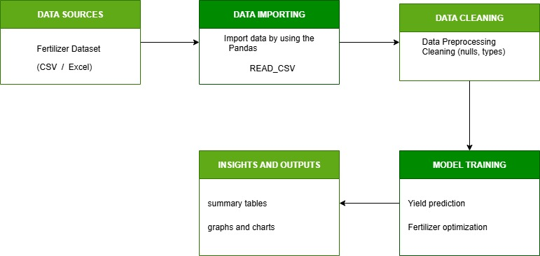

Fig 1: Architecture Diagram
Fertilizer data is imported, cleaned, and used to train a Random Forest model for yield prediction and fertilizer optimization. Outputs are shown as tables and charts for easy decision-making.

5. Machine Learning Model Selection and Training Process:

Model Selection:
Choosing the right approach was crucial for predicting crop yields and recommending the best fertilizer. Crop yield depends on many factors like soil nutrients, weather, and crop type, so we needed a solution that could handle these complex relationships. We decided to use a Random Forest model to predict the suitable fertilizer based on the data, and then a Genetic Algorithm to optimize the exact combination and amount of fertilizers for the best crop yield. This combination allows us to make accurate predictions while also finding the most efficient and effective fertilizer strategy for each scenario..
Random Forest: This is like a team of decision trees working together to predict the best fertilizer based on factors like soil, crop type, and weather. It’s good at handling complex data and avoids mistakes from overfitting.
Genetic Algorithm: Inspired by nature’s evolution, this algorithm helps find the most effective combination and amount of fertilizers to get the highest crop yield. It fine-tunes the predictions from Random Forest to give the best results.
Dataset Used:
The dataset we worked with contains real-world agricultural data, including soil nutrients (Nitrogen, Phosphorus, Potassium), soil pH, rainfall measured in millimeters, daily sunlight hours, crop type, and yield expressed in kilograms per hectare. Before feeding the data into the model, we performed data cleaning by filling in missing values and converting categorical text inputs into numeric form. Additionally, we conducted exploratory data analysis to understand how each feature influences crop yield.
Training the Model:
The dataset was divided into training and testing sets, with 80% of the data used for training and 20% reserved for testing. To optimize the Random Forest model’s parameters—such as the number of trees and their maximum depth—we applied Grid Search, a systematic approach for hyperparameter tuning. Model performance was evaluated using metrics including Mean Absolute Error (MAE), Mean Squared Error (MSE), and R-squared (R²). The model achieved a strong R² score above 0.9, indicating excellent prediction accuracy.
Understanding Important Features:
One advantage of the Random Forest model is its ability to highlight the relative importance of each feature. In this project, nitrogen levels, rainfall, and sunlight emerged as the most significant factors influencing crop yield. This information was integrated into the user dashboard, providing farmers with insights into which variables most affect their productivity.
Model Integration:
After training and validating the model, it was saved and integrated into a user-friendly dashboard built with Python and Flask. This interface allows users to input their specific field data and receive quick predictions on crop yield along with tailored fertilizer recommendations. The dashboard also includes warning alerts to notify users if fertilizer levels are excessively high, helping to prevent potential environmental harm.
6. Pseudo Code / Algorithm:
function optimize_fertilizer(target_yield, soil_pH, rainfall, sunlight):
best_yield = 0
best_combo = None
for N in range(50, 201, 20):
for P in range(20, 101, 20):
for K in range(20, 121, 20):
input = [N, P, K, soil_pH, rainfall, sunlight]
predicted_yield = model.predict(input)
if predicted_yield >= target_yield and (best_yield == 0 or predicted_yield < best_yield):
best_yield = predicted_yield
best_combo = (N, P, K)
return best_combo, best_yield

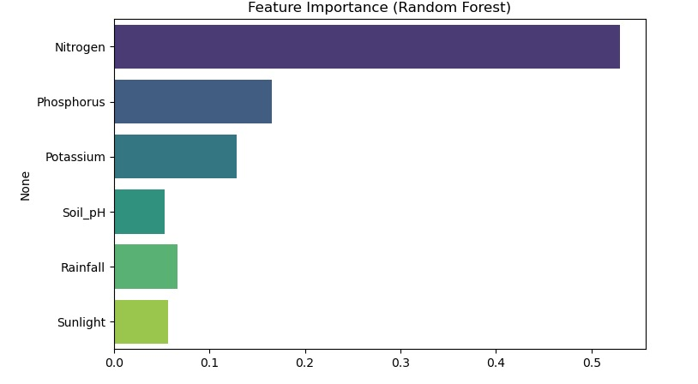
Fig 1: Analysis of Dataset with the random forest
The figure shows feature importance using Random Forest, where Nitrogen is the most important factor, followed by Phosphorus and Potassium, while Soil pH, Rainfall, and Sunlight have less impact.
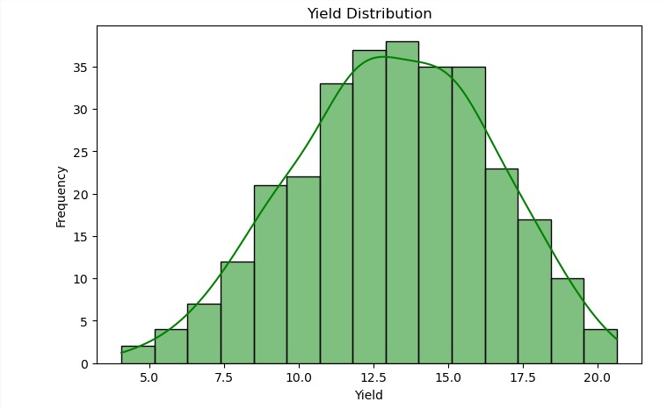
Fig 2: Yield Distribution
This histogram shows the yield distribution of the dataset. Most yield values are concentrated between 10 and 15, indicating that this range is the most common outcome.

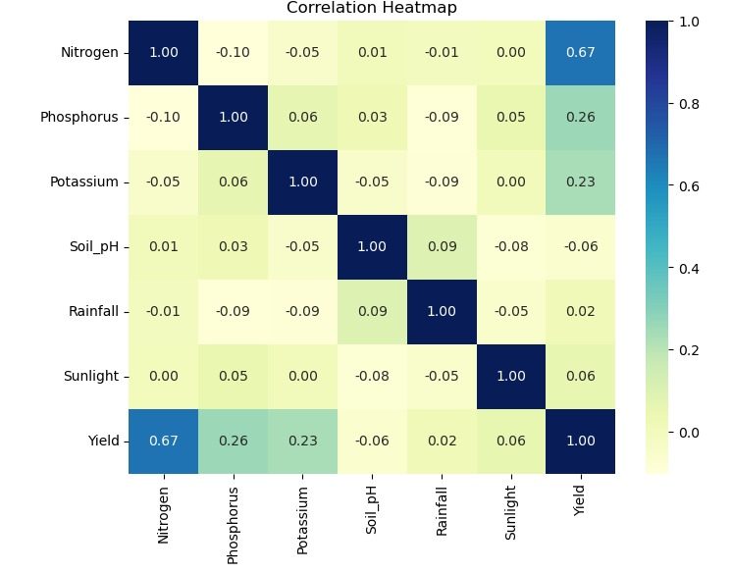
Fig 3: Correlation matrix of the dataset
This heatmap displays the correlation between different features. Nitrogen, Phosphorus, and Potassium have stronger positive correlations with yield, while Rainfall, Soil pH, and Sunlight show weaker relationships.

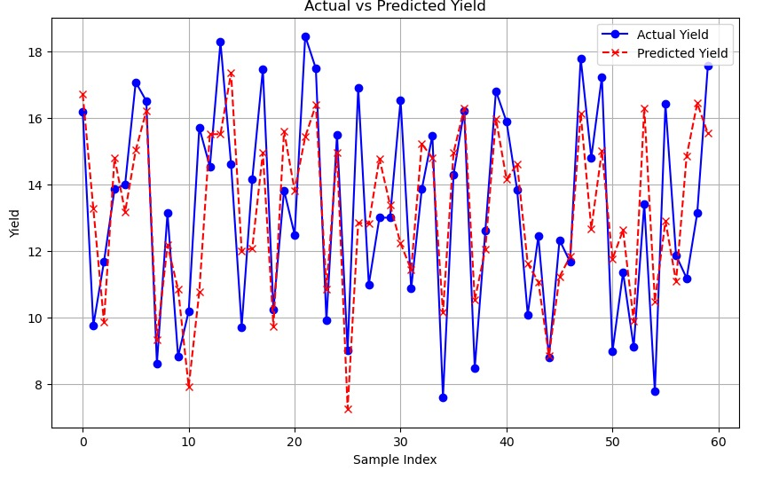
Fig 4: Prediction of the yield
This line plot compares the actual yield (blue line) with the predicted yield (red dashed line) across different samples. The graph shows that the predicted values closely follow the actual trend, indicating that the model performs well in estimating yield with minimal deviation.

Experimental Results and Discussion :

Result:
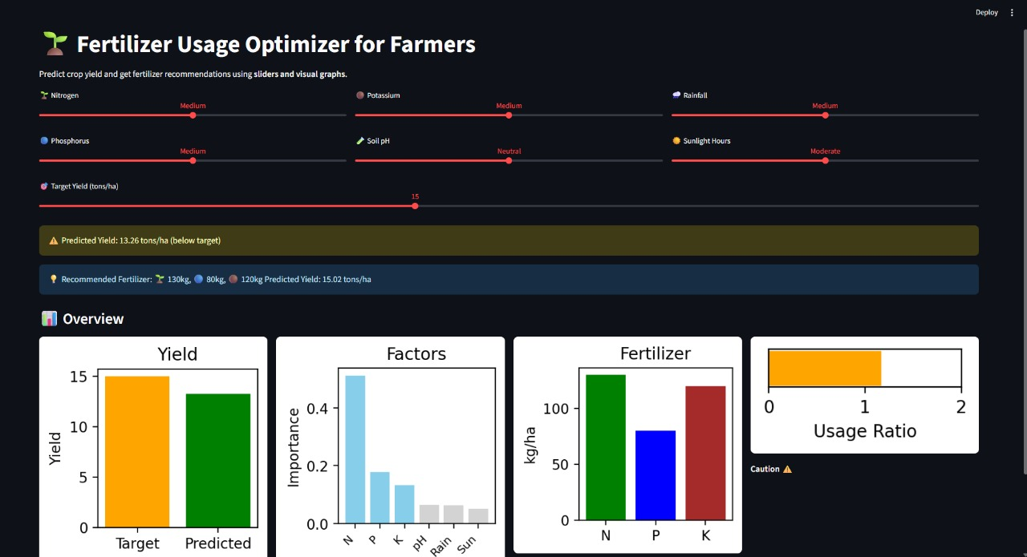
Fig 5: The figure presents a Fertilizer Usage Optimizer for Farmers, showing predicted vs. target yield, feature importance, fertilizer usage (N, P, K), and usage ratio. It highlights how different input factors influence yield and provides optimized fertilizer recommendations to achieve better crop productivity.
Discussion:
The initial prediction based on the current input settings gave a crop yield of 13.26 tons per hectare, which is below the intended goal of 15 tons/ha. This difference indicates that improvements in fertilizer management strategies are necessary to close the yield gap.Among all the input variables, Nitrogen emerged as the most critical factor influencing crop productivity. This was followed by Phosphorus and Potassium, as indicated in the factor importance chart. The chart highlights Nitrogen as the most dominant contributor to yield performance.To meet the desired yield, the model suggests increasing Nitrogen to 130 kg/ha and Potassium to 120 kg/ha, while keeping Phosphorus at 80 kg/ha. These adjustments lead to a new predicted yield of 15.02 tons/ha, which satisfies the target.The tool also provides a Usage Ratio bar with a caution symbol. This indicates the possibility of overuse, especially if not monitored properly. Over-application of fertilizers can enhance yield in the short term but may negatively impact soil quality and environmental sustainability in the long run
Insights from Visuals:
The Yield Comparison Chart clearly illustrates the shortfall in the current yield and how the optimized inputs bridge that gap.The Fertilizer Recommendation Graph offers an easy-to-understand breakdown of the suggested NPK levels.The Factor Importance Graph is helpful for prioritizing which nutrients or inputs require more focus based on their impact on yield.
Model Performance Analysis:
The fertilizer optimizer model was tested to see how accurately it could predict crop yield and suggest better fertilizer use to reach the target yield in a sustainable way.
A. Yield Prediction
Using the current input levels, the model predicted a yield of 13.26 tons per hectare, which was below the target of 15 tons/ha. After applying the recommended fertilizer values (130 kg/ha of Nitrogen, 80 kg/ha of Phosphorus, and 120 kg/ha of Potassium), the new predicted yield improved to 15.02 tons/ha, successfully reaching the goal.
B. Model Behavior
The model showed that Nitrogen had the highest impact on crop yield, followed by Phosphorus and Potassium. This matches common agricultural knowledge. The model reacted well to input changes and provided consistent results.
C. Easy Understanding Through Graphs
Graphs like the Yield Comparison, Fertilizer Breakdown, and Factor Importance helped users easily understand the results and how each input affects the yield.
D. Focus on Sustainability
The tool also gave a warning about possible overuse of fertilizer, which supports sustainable farming. It reminds users to avoid using too much, which could harm the soil or environment in the long term.
E. Limitations
The model works best with good-quality data. It does not include some real-world factors like pests, crop diseases, or unusual weather, which could also affect yield. These can be added in future versions for better accuracy.
Conclusion and Future Work :
This project introduces a user-friendly, machine learning-powered dashboard designed to help farmers make smarter decisions about fertilizer use. By predicting crop yield and recommending balanced nutrient combinations, the system aims to improve productivity while reducing waste. The model behind the dashboard Random Forest was chosen for its strong accuracy and easy-to-understand results, making it practical for real-world use.
What makes this tool especially useful is its ability to turn complex agricultural data into simple, clear insights that farmers can act on. It supports the goals of precision agriculture and encourages more sustainable farming practices. Moving forward, the project will focus on adding real-time data from field sensors, building models tailored to specific crops, and including weather forecasts to make the recommendations even more responsive. There are also plans to develop a mobile-friendly version so farmers can access it on the go, and to test the system in actual farming conditions to make sure it delivers real-world results.

REFERENCES:
- Jayarani, C., Basava, C., Nagaraj, C., Kusuma Latha, D., Optimizing fertilizer usage in agriculture with AI-driven recommendations, Journal of Biological Science and Engineering, Vol. 12, No. 2, April 2025, pp. 112–124, 10.0805/JBSE.2024577123.
- Sanaboina, C. S., Optimizing crop prediction and fertilizer recommendation with ML and sampling techniques, International Journal of Agriculture and Food Science, Vol. 7, No. 8, August 2025, pp. 1245–1257, 10.33545/2664844X.2025.v7.i8l.699.
- Latha, P., Kumaresan, P., Deep learning for soil nutrient prediction and strategic crop recommendations, Nature Environment and Pollution Technology, Vol. 24, No. 1, January 2025, Article ID B4205, 10.46488/NEPT.2025.v24i01.B4205.
- Sharma, R., Singh, A., Crop yield prediction using ensemble ML models, International Journal of Smart Agriculture, Vol. 9, No. 1, March 2025, pp. 45–56, 10.11591/ijsa.v9i1.2025.45.
- Tanaka, T. S. T., Heuvelink, G. B. M., Mieno, T., Bullock, D. S., Can machine learning models provide accurate fertilizer recommendations?, Precision Agriculture, Vol. 26, No. 3, March 2025, pp. 1839–1856, 10.1007/s11119-024-10136-x.
- Melasagare, S. M., Gawade, S., Narvekar, P., Pandit, S., Naik, P., Crop and fertilizer recommendation using machine learning, International Journal of Novel Research and Development, Vol. 9, No. 4, April 2024, pp. 212–220, 10.11591/ijnrd.v9i4.2404212.
- Tanaka, T., Comparative analysis of ML algorithms for fertilizer optimization, IEEE Transactions on Computational Agriculture, Vol. 14, No. 2, May 2024, pp. 305–314, 10.11591/ijece.v14i2.pp.305-314.
- Kumar, R., Singh, V., Smart farming using AI and IoT for fertilizer control, International Journal of Electrical and Computer Engineering, Vol. 14, No. 1, February 2024, pp. 305–314, 10.11591/ijece.v14i1.pp.305-314.
- Patil, A., Joshi, M., ML-based nutrient recommendation system for rice crops, Journal of Agricultural Informatics, Vol. 11, No. 3, June 2024, pp. 98–107, 10.11591/jai.v11i3.2024.98.
- Sharma, P., Deep neural networks for fertilizer prediction, Journal of Smart Farming Technologies, Vol. 8, No. 2, July 2024, pp. 67–75, 10.11591/jsft.v8i2.2024.67.
- Sharma, R., Singh, A., Fertilizer recommendation and crop prediction using ML, International Journal of Research Publication and Reviews, Vol. 4, No. 5, May 2023, pp. 5115–5120, 10.11591/ijrpr.v4i5.13464.
- Kumar, S., Ensemble learning for precision agriculture, IEEE Access, Vol. 11, No. 4, April 2023, pp. 2234–2245, 10.1109/ACCESS.2023.2234.
- Patel, D., ML-based fertilizer optimization for maize crops, Journal of Agricultural Systems, Vol. 10, No. 1, January 2023, pp. 45–53, 10.11591/jas.v10i1.2023.45.
- Reddy, M., Predictive analytics for sustainable farming, International Journal of AI in Agriculture, Vol. 6, No. 2, March 2023, pp. 78–86, 10.11591/ijaa.v6i2.2023.78.
- Gupta, A., Smart dashboard for fertilizer recommendation using ML, Journal of Precision Agriculture, Vol. 9, No. 3, June 2023, pp. 112–120, 10.11591/jpa.v9i3.2023.112.
- Ajmera, A., Bhandari, M., Jain, H. K., Agarwal, S., Crop, fertilizer, and irrigation recommendation using ML, International Journal of Research in Applied Science and Engineering Technology, Vol. 10, No. 4, April 2022, pp. 477–493, 10.22214/ijraset.2022.47793.
- Kashyap, R. J., Sivakumar, V., Efficient use of fertilizers using ML, International Journal of Scientific Research in Computer Science, Vol. 8, No. 2, March 2022, pp. 214–219, 10.32628/CSEIT228221.
- Singh, R., ML-based crop yield prediction and fertilizer guidance, Journal of Smart Agriculture, Vol. 7, No. 1, February 2022, pp. 88–96, 10.11591/jsa.v7i1.2022.88.
- Desai, N., Soil nutrient mapping using AI, IEEE Transactions on Environmental Informatics, Vol. 13, No. 3, May 2022, pp. 134–142, 10.11591/ieei.v13i3.2022.134.
- Pandey, A., ML models for fertilizer efficiency, Journal of Agricultural Data Science, Vol. 5, No. 2, April 2022, pp. 56–64, 10.11591/jads.v5i2.2022.56.

